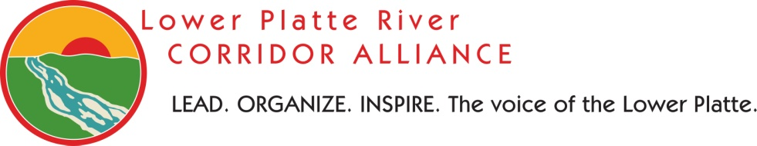
QUARTERLY MEETING DRAFT AGENDA
Tuesday, October 27, 2015 6:00 p.m.
Papio-Missouri River NRD
8901 S. 154th St
Omaha, NE 68138

- Call to Order / Introductions
- Proof of Legal Notice/Publication
- Adoption of Agenda [ACTION]
- Approval of LPRCA Minutes from August 4, 2015 Meeting [ACTION]
- Platte River Venture Parks—Jim Swenson, NGPC
- Cass County Silver Jackets Project—Mitch Paine, DNR
- River Obstruction Removal at Two Rivers Recreation Area Update and Discussion
- Lower Platte River Basin Plan Update
- NRD Integrated Management Plans Updates
- WRDA Authorized Project Updates
  - Deadman’s Run
  - Sand Creek
  - Fremont & Schuyler 205
  - Western Sarpy Clear Creek
  - Lower Platte River Watershed Authority
- Next Meeting Date [ACTION]
- Public Comment

- Adjourn
NOTES
- To be removed from/ added to our mailing or e-mailing list, please contact the LPRCA at (402) 476-2729 or via e-mail at msittler@lpsnrd.org.
- Meeting information (past and present) will be kept up to date at: http://www.lowerplatte.org/what_we_do/quarterly_meetings.html

